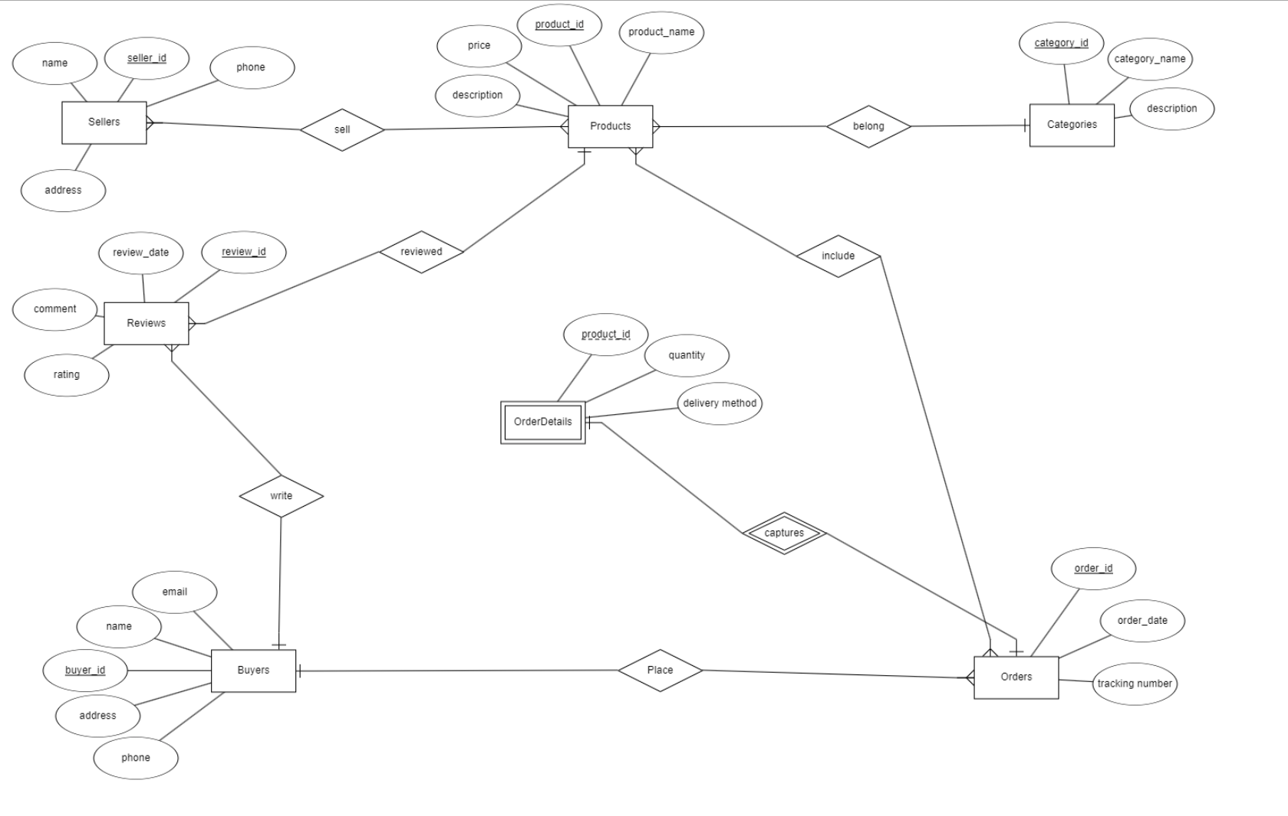

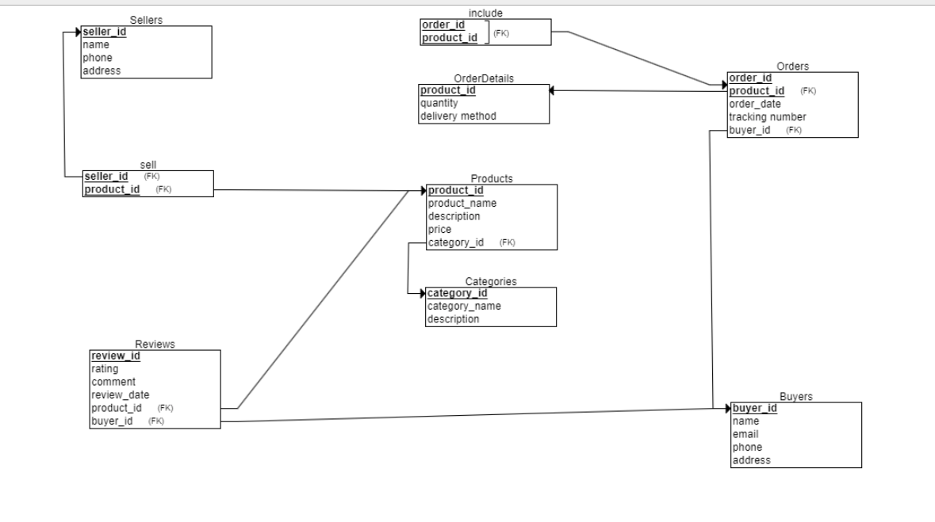

CREATE TABLE Sellers (

name VARCHAR2(20) NOT NULL, *-- Changed INT to VARCHAR2(20) for name*

seller_id INT NOT NULL,

phone VARCHAR2(20) NOT NULL, *-- Changed INT to VARCHAR2(20) for phone numbers*

address VARCHAR2(200) NOT NULL, *-- Changed INT to VARCHAR2(200) for address*

PRIMARY KEY (seller_id)

);

CREATE TABLE Categories (

category_id INT NOT NULL,

category_name VARCHAR2(200) NOT NULL, *-- Changed INT to VARCHAR2(200) for category name*

description VARCHAR2(2000), *-- Changed INT to VARCHAR2(2000) for description (optional)*

PRIMARY KEY (category_id)

);

CREATE TABLE OrderDetails (

product_id INT NOT NULL,

quantity INT NOT NULL,

delivery_method VARCHAR2(20) NOT NULL,

PRIMARY KEY (product_id)

);

CREATE TABLE Buyers (

buyer_id INT NOT NULL,

name VARCHAR2(200) NOT NULL, *-- Changed INT to VARCHAR2(200) for name*

email VARCHAR2(255) NOT NULL, *-- Changed INT to VARCHAR2(255) for email*

phone VARCHAR2(20) NOT NULL, *-- Changed INT to VARCHAR2(20) for phone number*

address VARCHAR2(200) NOT NULL, *-- Changed INT to VARCHAR2(200) for address*

PRIMARY KEY (buyer_id)

);

CREATE TABLE Products (

product_id INT NOT NULL,

product_name VARCHAR2(200) NOT NULL, *-- Changed INT to VARCHAR2(200) for product name*

description VARCHAR2(2000), *-- Changed INT to VARCHAR2(2000) for description (optional)*

price NUMBER(10,2) NOT NULL, *-- Use NUMBER for price with precision (10) and scale (2)*

category_id INT NOT NULL,

PRIMARY KEY (product_id),

FOREIGN KEY (category_id) REFERENCES Categories(category_id)

);

CREATE TABLE Orders (

order_id INT NOT NULL,

order_date DATE NOT NULL, *-- Use DATE for date*

tracking_number VARCHAR2(20) NOT NULL,

product_id INT NOT NULL,

buyer_id INT NOT NULL,

PRIMARY KEY (order_id, product_id),

FOREIGN KEY (product_id) REFERENCES OrderDetails(product_id),

FOREIGN KEY (buyer_id) REFERENCES Buyers(buyer_id)

);

CREATE TABLE Reviews (

review_id INT NOT NULL,

rating NUMBER(10,1), *-- Use NUMBER for rating with precision (10) and scale (1)*

comment_text VARCHAR2(2000), *-- Changed INT to VARCHAR2(2000) for comment*

review_date DATE NOT NULL, *-- Use DATE for date*

product_id INT NOT NULL,

buyer_id INT NOT NULL,

PRIMARY KEY (review_id),

FOREIGN KEY (product_id) REFERENCES Products(product_id),

FOREIGN KEY (buyer_id) REFERENCES Buyers(buyer_id)

);

CREATE TABLE sell (

seller_id INT NOT NULL,

product_id INT NOT NULL,

PRIMARY KEY (seller_id, product_id),

FOREIGN KEY (seller_id) REFERENCES Sellers(seller_id),

FOREIGN KEY (product_id) REFERENCES Products(product_id)

);

CREATE TABLE include_products (

order_id INT NOT NULL,

product_id INT NOT NULL,

PRIMARY KEY (order_id, product_id),

FOREIGN KEY (order_id, product_id) REFERENCES Orders(order_id, product_id)

);

*-- dropTables.sql*

*-- Drop the tables in the reverse order of their creation to ensure all dependencies are handled properly*

DROP TABLE include_products CASCADE CONSTRAINTS;

DROP TABLE sell CASCADE CONSTRAINTS;

DROP TABLE Reviews CASCADE CONSTRAINTS;

DROP TABLE Orders CASCADE CONSTRAINTS;

DROP TABLE Products CASCADE CONSTRAINTS;

DROP TABLE Buyers CASCADE CONSTRAINTS;

DROP TABLE OrderDetails CASCADE CONSTRAINTS;

DROP TABLE Categories CASCADE CONSTRAINTS;

DROP TABLE Sellers CASCADE CONSTRAINTS;

*-- End of dropTables.sql*

insert

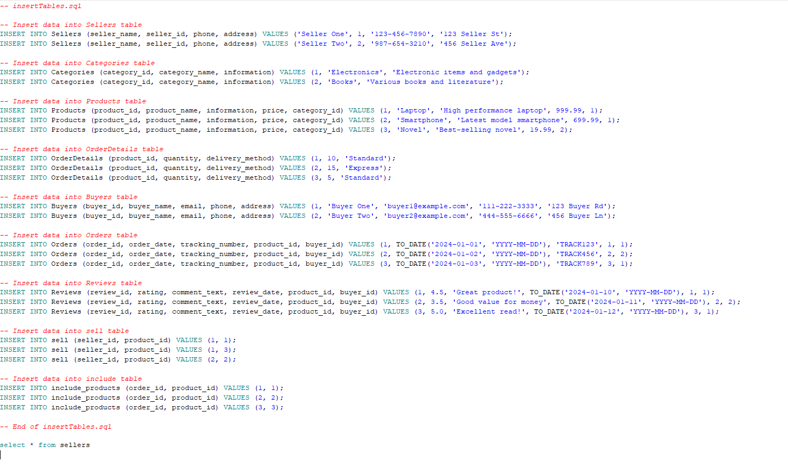

generate

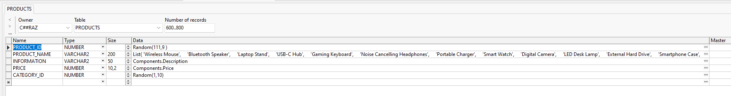

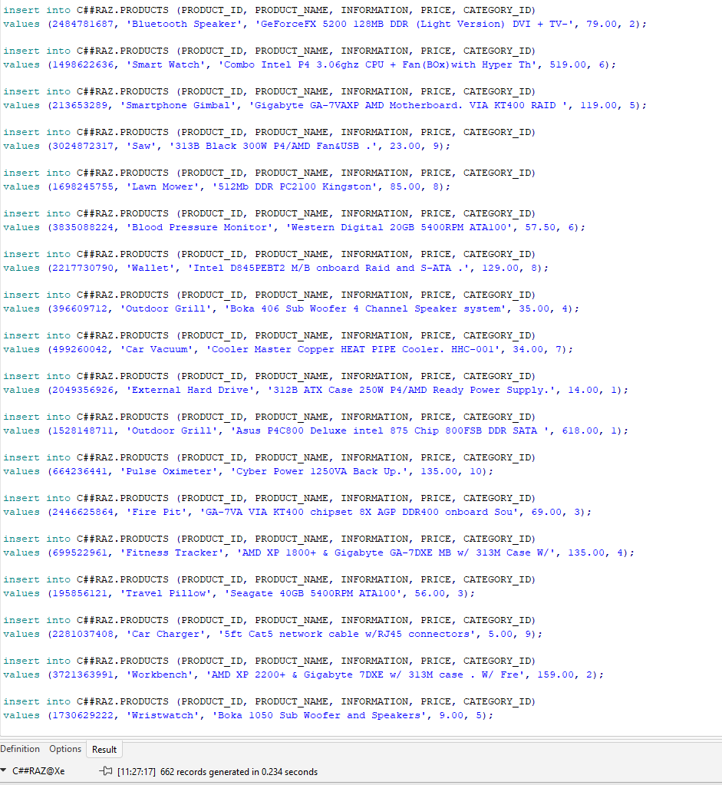

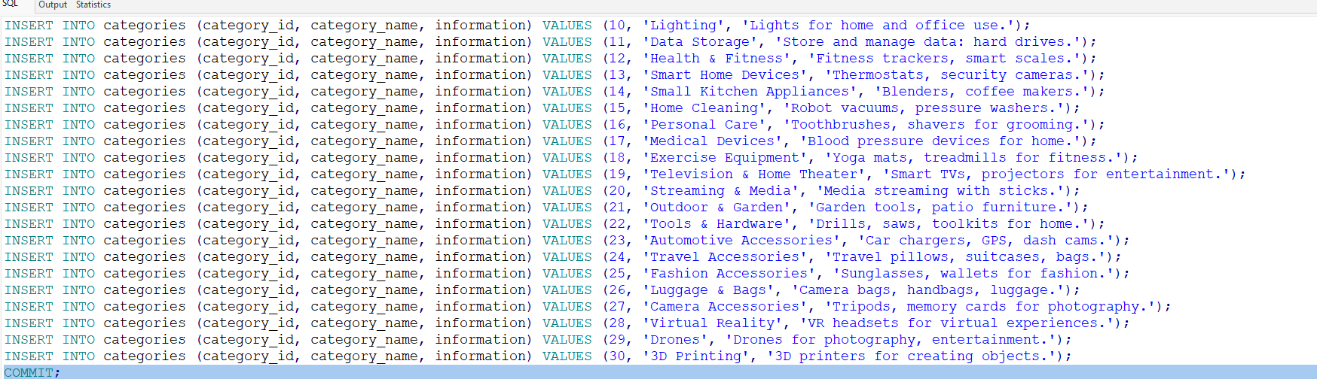

txt

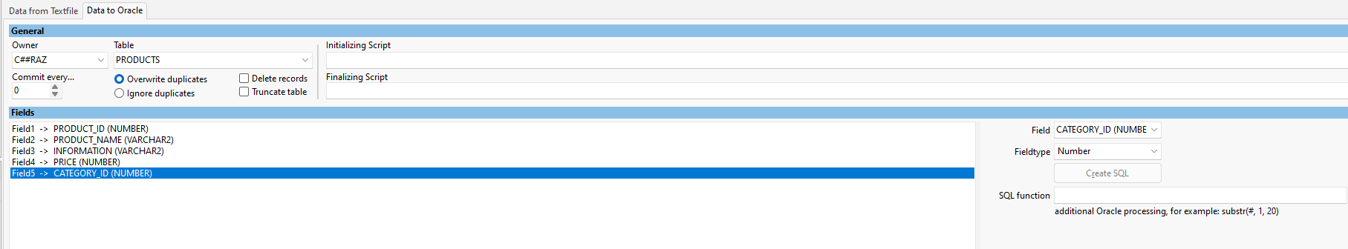

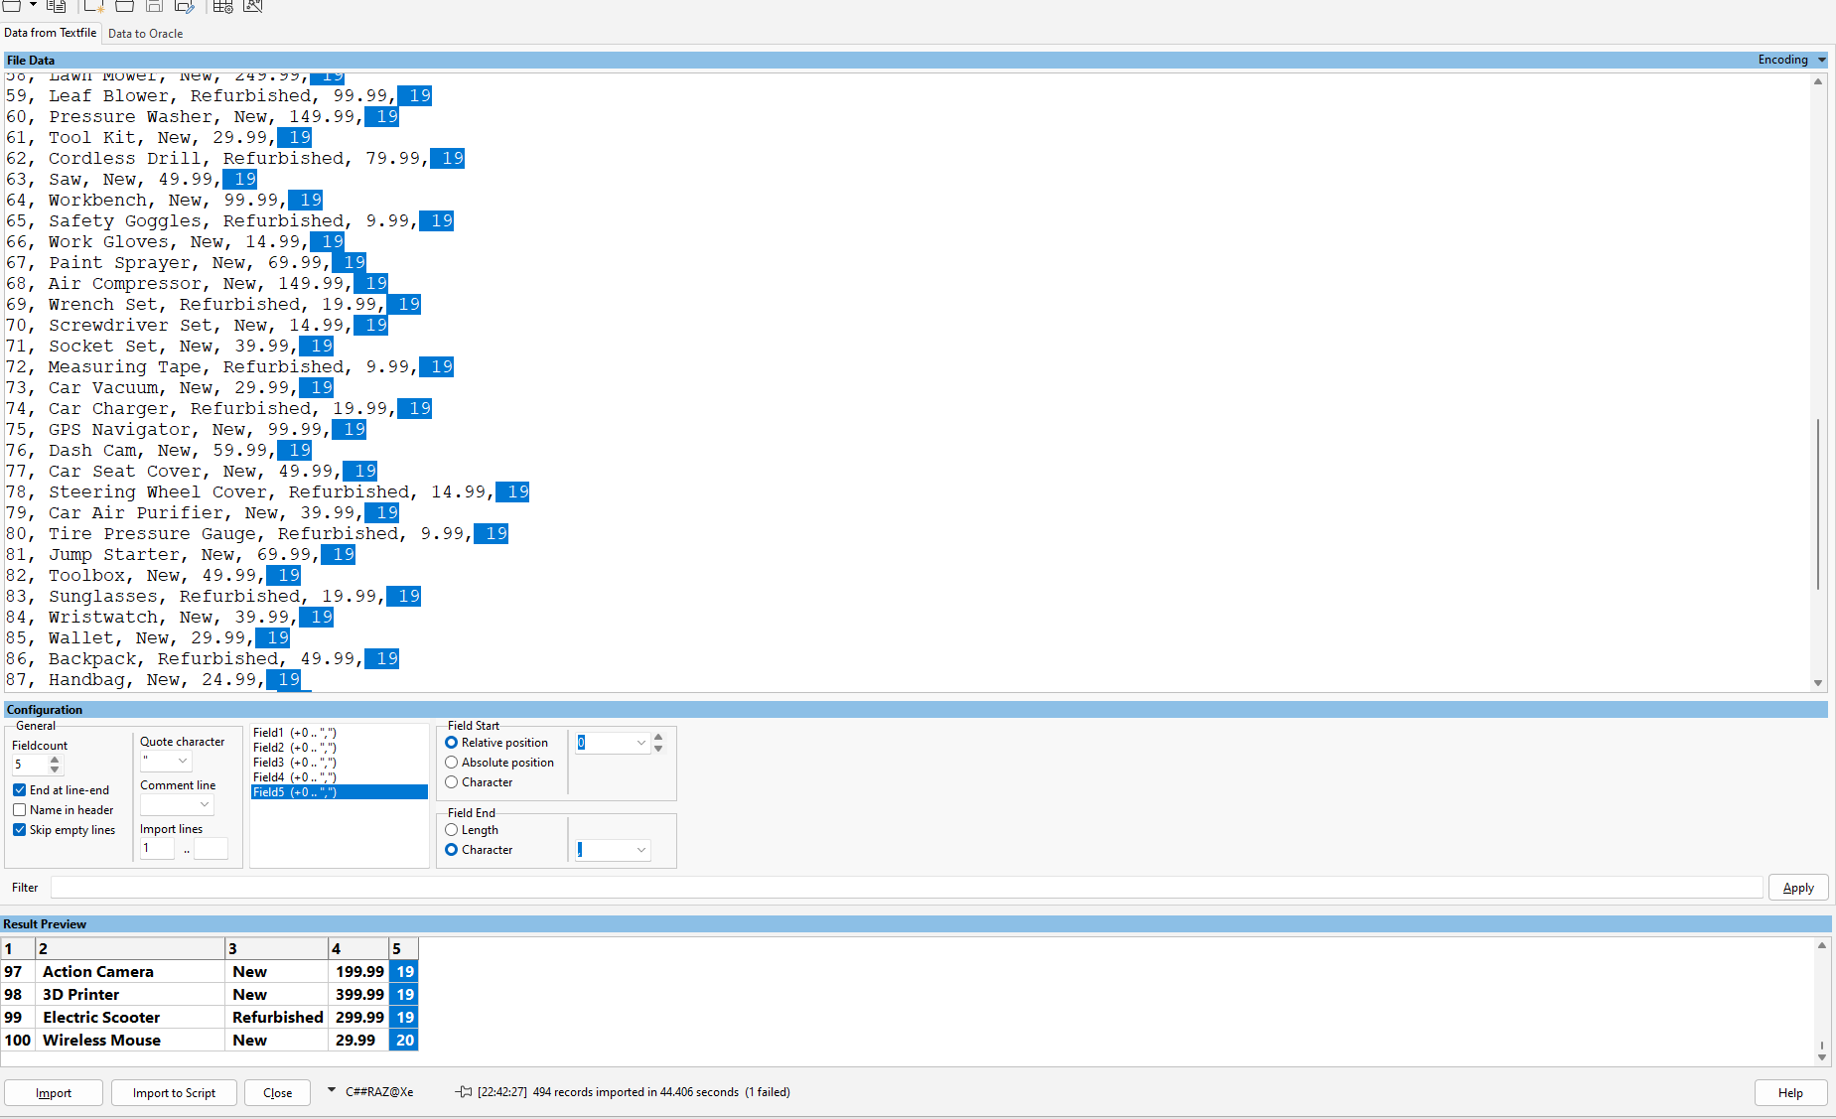

mockaroo

